Milestone 4: Model Interpretability, Deployment and Production Readiness

1. Introduction
After finalizing LightGBM as the optimal predictive model in Milestone 3, this milestone focuses on transforming the validated model into a production-ready system. Beyond predictive accuracy, real-world machine learning systems must ensure interpretability, reliable deployment, and long-term maintainability.
Accordingly, this milestone integrates model explainability, deployment architecture, inference pipeline design, and model lifecycle considerations, completing the end-to-end development workflow.

2. Model Interpretability Using SHAP
To ensure transparency and trust in model predictions, SHAP-based explainability techniques were applied to the final LightGBM model. SHAP provides a unified framework to quantify feature contributions, enabling both global and feature-level insights into model behavior.
Explainability analysis was intentionally conducted after model selection to ensure that interpretations reflect the final deployed model.

3. Global Feature Contribution Analysis

The SHAP summary plot presents the relative importance and directional impact of features across all predictions. Features related to market dynamics, transfer history, and team context emerge as the most influential drivers of player valuation.
Positive contributions are primarily associated with indicators of recent market strength and competitive exposure, while age- and injury-related features exert downward pressure on predicted value. Importantly, the model does not rely excessively on any single feature, indicating a balanced and stable decision process.
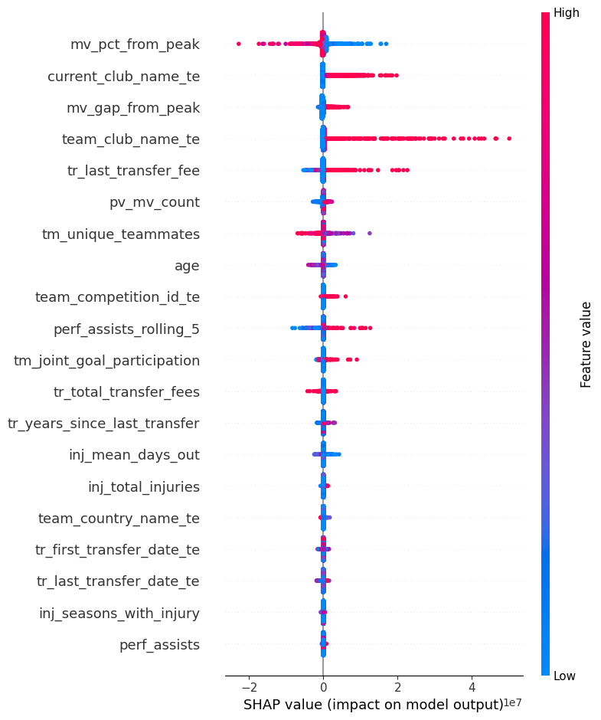
Figure 1: SHAP Summary Plot Showing Global Feature Contributions

4. Feature Interaction and Non-Linear Behavior
To further understand complex model behavior, SHAP dependence analysis was conducted. The dependence plot illustrates a non-linear relationship between a player’s proximity to peak market value and predicted valuation, while highlighting interaction effects with recent transfer fees.
The observed diminishing returns near peak valuation align with real-world football economics, where incremental value growth slows as players approach their perceived maximum potential. This confirms that the model captures meaningful interaction effects rather than simplistic linear patterns.
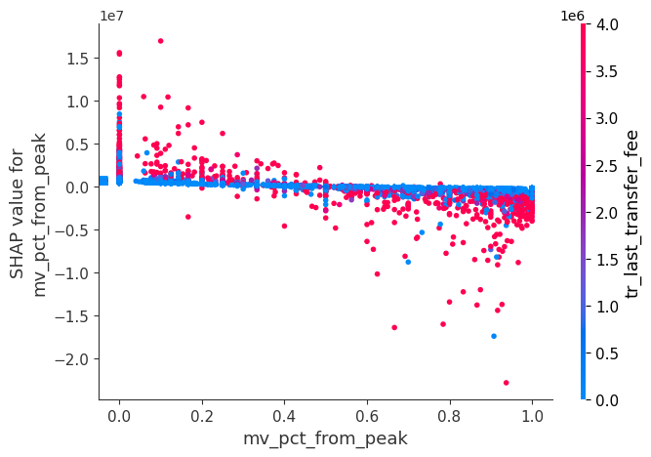
Figure 2: SHAP Dependence Plot for mv_pct_from_peak with Transfer Fee Interaction

5. Model Serialization and Reproducibility
Following validation and explainability analysis, the trained LightGBM model was serialized using a binary persistence format (pickle). Model serialization ensures:
- Consistent predictions across environments
- Reproducibility of results
- Efficient deployment without retraining
In addition to the model, preprocessing artifacts such as feature ordering and transformation logic were preserved to prevent discrepancies between training and inference stages.

6. Deployment Architecture and Streamlit Interface
To enable user interaction and real-time inference, the model was integrated into a Streamlit-based web application. The interface allows users to input player-related attributes and receive instant market value predictions.

The deployment workflow consists of:
- User input collection through the Streamlit UI
- Feature preprocessing using the saved transformation pipeline
- Model inference using the serialized LightGBM model
- Display of predicted market value to the end user
This architecture demonstrates the practical applicability of the model beyond offline experimentation.

7. Input–Output Prediction Pipeline
A standardized input–output pipeline was designed to ensure consistency and reliability during inference. Raw inputs are validated, transformed, and mapped to the model’s expected feature schema before prediction.
This pipeline guarantees:
- Alignment between training and inference data formats
- Robust handling of missing or incomplete inputs
- Stable and repeatable predictions across sessions
Such pipeline design is critical for preventing training–serving skew in deployed machine learning systems.

8. Model Limitations
Despite strong performance, certain limitations were identified:
- Predictions may be less reliable for players with limited historical data.
- Sentiment features can be noisy for low-visibility players.
- Sudden market shocks (e.g., major injuries or transfers) may not be immediately reflected.
Recognizing these limitations helps contextualize predictions and guides responsible usage.

9. Monitoring and Retraining Strategy
To maintain long-term model relevance, a monitoring and retraining strategy was defined. Model performance should be periodically evaluated using newly available season and transfer data.
Triggers for retraining include:

- Sustained degradation in prediction accuracy
- Distribution shifts in key features
- Emergence of new market patterns
This strategy ensures that the model evolves alongside changing football market dynamics.

Milestone 4 Outcomes
This milestone completed the transition from a validated machine learning model to a fully deployable and interpretable prediction system. By combining explainability, deployment, and lifecycle planning, the project demonstrates a production-oriented approach consistent with industry best practices.

Final Project Conclusion
This project delivers a complete, end-to-end solution for football player market value prediction. Beginning with multi-source data integration and advanced feature engineering, the workflow progressed through systematic model development, rigorous validation, explainability analysis, and production deployment.
The final LightGBM model achieves strong predictive accuracy while maintaining transparency through SHAP-based explanations. Deployment via a Streamlit interface and a standardized inference pipeline ensures practical usability, while clearly defined monitoring and retraining strategies support long-term sustainability.
Overall, the project exemplifies a real-world machine learning system that balances accuracy, interpretability, and operational readiness, making it suitable for both analytical exploration and decision-support applications.

